

Our ref: Kfem/2645/Circular/qsh

27 October 2009

To: All Residents of Ardmore Park

Proper Disposal of Refuse

To prevent pest infestation and odour emission, please put all loose garbage, especially wet waste (which should be drained dry) into tightly sealed plastic bags before disposing them into the refuse chutes. If you have domestic helpers who are handling the disposal of your garbage, please instruct them to do so accordingly.

Bulky waste, flower pots, plants or glass bottles must not be thrown into the refuse chutes because these items may cause injury to the handlers who are clearing the bins below. The weight of these items will also damage the collection bins causing them to crack and leak.

If you have any bulky waste items such as flower pots, tables and chairs and other loose furniture that you want to discard, you may call the management office at 6 7330 862 to arrange for their proper disposal. All glass bottles and newspapers are to be placed at your back doors for collection by our cleaners every morning.

Hanging of Laundry at the Balconies

We noticed that some residents hang their laundry at their balconies. Kindly note that this is in breach of our By-Laws 27.1 (a) and (b):

Clause 27.1
It is intended that the exterior façade of the building shall represent a uniform appearance at all times. In order to ensure this, the following restrictions shall apply to all subsidiary proprietors, tenants, occupiers or residents of Ardmore Park: -

(a) No laundry, bedding, clothing or any other articles shall be hung at the balconies or by the windows in such manner as to be visible from the exterior of the subdivided building;

(b) No laundry poles, clothing lines or other fixtures (whether temporary or permanent) shall be used in such a manner as to extend and/or project out of the balconies or windows of any lot or unit to the exterior of the subdivided building

Your co-operation to comply with the above By-Laws is greatly appreciated. For residents who are new to Ardmore Park, you may obtain a copy of the By-Laws from the Management Office or download it from our website: www.ardmorepark.com.sg

Thank you for your attention.

Yours Faithfully,
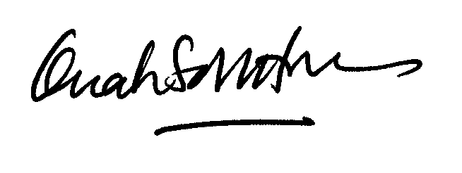

Quah Soh Hoon
General Manager
Ardmore Park
For and on behalf of The Management Corporation Strata Plan No. 2645

